 CHEMICAL ENGINEERING TRANSACTIONS  VOL. , 2026 | A publication of  
The Italian Association
of Chemical Engineering
Online at www.cetjournal.it

Guest Editors:
Copyright © 2025, AIDIC Servizi S.r.l.
ISBN 979-12-81206-XX-X; ISSN 2283-9216

Evaluation of the impact of hexagonal shaped HDPE elements coverage on emissions from a municipal solid waste landfill leachate reservoir
E. Gallegoª*, J.F. Peralesª, N. Aguasca^{b}
ª Laboratori del Centre de Medi Ambient, Escola d’Enginyeria de Barcelona Est (EEBE), Universitat Politècnica de Catalunya · Barcelona Tech (UPC), Av. Eduard Maristany 16, 08019 Barcelona, Spain.
^{b} Prezero Gestión de Residuos, Dipòsit Controlat de Can Mata, carretera B-231, 080781 Els Hostalets de Pierola, Spain.

eva.gallego@upc.edu

The effectiveness of odour emission reduction in a municipal solid waste landfill leachate reservoir was evaluated using hexagonal-shaped HDPE cover elements. A previous study conducted in 2020 identified H₂S as the dominant contributor to odour emissions from the leachate reservoir, accounting for 99% of total odour units (O.U.). To mitigate these emissions, HDPE hexagonal covers were installed over the leachate basin in 2024. The performance of this system was assessed by analysing changes in H₂S concentrations. New measurements carried out in 2025, using Radiello diffusive samplers as in the previous campaign, showed that H₂S concentrations decreased from 0.8–1.1 mg m⁻³ in 2020 to 0.09–0.14 mg m⁻³ in 2025, after installation. By applying odour thresholds to the measured concentrations, odour units were determined, revealing a reduction from 1129–1609 O.U. to 128–198 O.U. This corresponds to an average decrease of 87.8% in measured concentrations and associated odour impact. Numerical modelling using the TAPM dispersion model was applied to estimate emission factors, incorporating meteorological conditions to ensure a consistent comparison between 2020 and 2025 data. The modelling results confirmed a substantial emission reduction, estimated at 86.2%. Overall, the use of hexagonal-shaped HDPE elements to cover leachate basins in municipal solid waste landfillshas proven to be a highly effective solution for reducing odorous emissions.
  - Introduction
Municipal solid waste landfills can generate odorous impacts in surrounding areas (Oliva et al., 2024, Izadi et al., 2026, Lakhouit, 2026), with gas emissions varying considerably due to factors such as site operations, environmental and meteorological conditions, waste composition, and seasonal changes (Muezzinoglu, 2025). Several cover systems are available for odour emission mitigation in landfills (Lakhouit, 2026), depending on the source and purpose, e.g. HDPE geomembrane-based artificial covers for temporal dumped organic waste (Vizuete-Montero et al., 2025), or biocovers in the final cover systems (Zhang et al., 2024, Verma et al., 2025). Additionally, hexagon-shaped HDPE elements can be used to prevent leachate evaporation from reservoir basins.
Can Mata landfill (Els Hostalets de Pierola, Catalonia, Spain) leachate reservoir emission factor was calculated using an inverse methodology in 2020 in a previous study. The main aim of the study was to determine emission factors from several key point sources of the landfill (i.e. the pre-closed area, the dumping area and the leachate reservoir), for the determination of its polluting and odorous impacts (Gallego et al., 2024). The application of numerical modelling techniques to determine the impact of potentially emitting activities in their surroundings, such as landfills, is a highly valuable tool for facility management (Szałata et al., 2021, Zhang et al., 2021, Lakhouit, 2026).
Can Mata is a landfill where approximately 900.000 tons of municipal and non-hazardous waste are disposed of annually, with an exceptional volume of 1 Mt managed in 2025. Biogas is recovered from the process, generating approximately 40 million of m³ of raw biogas per year. In July 2020, ambient air concentrations at 1 m above the ground of volatile organic compounds (VOCs), hydrogen sulphide (H₂S) and ammonia (NH₃) were determined in the potentially emission sources of the landfill for the determination of emission factors. In the leachate reservoir, total VOC (TVOC) concentrations were found in the range of 0.3-0.6 mg m⁻³. On the other hand, H₂S and NH₃ concentrations presented values of 0.8-1.1 mg m⁻³ and 1.7-1.8 mg m⁻³, respectively. With the application of odour thresholds to the concentrations obtained, the most critical compounds regarding odour annoyances were determined, and their related odour units (O.U.) established. In the leachate reservoir, the highest odour units (O.U.) were mainly associated to H₂S concentrations. O.U. related to H₂S, NH₃ and TVOC concentrations were in the range of 1129-1609 O.U., 1 O.U. and 12-16 O.U., respectively, H₂S accounting for an average value of 99% of total odour units (Gallego et al., 2024). High odours related H₂S in the leachate basins are caused by its low odour threshold (Ren et al., 2025) as well as by its concentration in the leachate, which can pose a significant operational challenge. High leachate H₂S concentrations can hasten the deterioration of infrastructure and disrupt the efficiency of subsequent treatment systems (D’Aoust et al., 2026).
In order to minimize H₂S emissions and thereby reduce odour impacts from Can Mata landfill, hexagon-shaped HDPE elements were installed in 2024 to reduce evaporation from the leachate basins. The present study, hence, aims to evaluate differences in polluting/odorous emissions from the cited basin from year 2020, without any cover, and 2025, with the hexagonal shaped HPDE elements.
  - Methodology
    - Chemicals and materials
H₂S (RAD170) cartridge adsorbents and Radiello Mehylene blue calibration standard for H₂S were obtained from Merck (Damstadt, Germany).
    - Sampling strategy
Since H₂S was the main contributor to odours emitted from the leachate reservoir, the evaluation of the hexagon-shaped HDPE elements focused solely on changes in H₂S concentrations to assess their effect on odour reduction. NH₃ and TVOC emissions were considered to remain at 2020 levels. During the 2020–2025 period, Can Mata landfill maintained consistent waste input typologies, disposal volumes, and leachate basin operating conditions. As these key operational parameters remained unchanged throughout the study period, no significant variations in emissions attributable to changes in waste composition or landfill operational status were expected.
To determine H₂S concentrations in the leachate basin, H₂S was sampled in September 2025 as had been done previously in July 2020. Radiello H₂S cartridge adsorbents (reference RAD170) were exposed during several days (in duplicate), using their corresponding diffusive bodies (reference RAD 120), in three different representative points of the leachate basin (Figure 1). The three sampling points were selected along the perimeter of the 4,500 m³ leachate pond on the downwind side, ensuring representative coverage of the area of potential emissions.

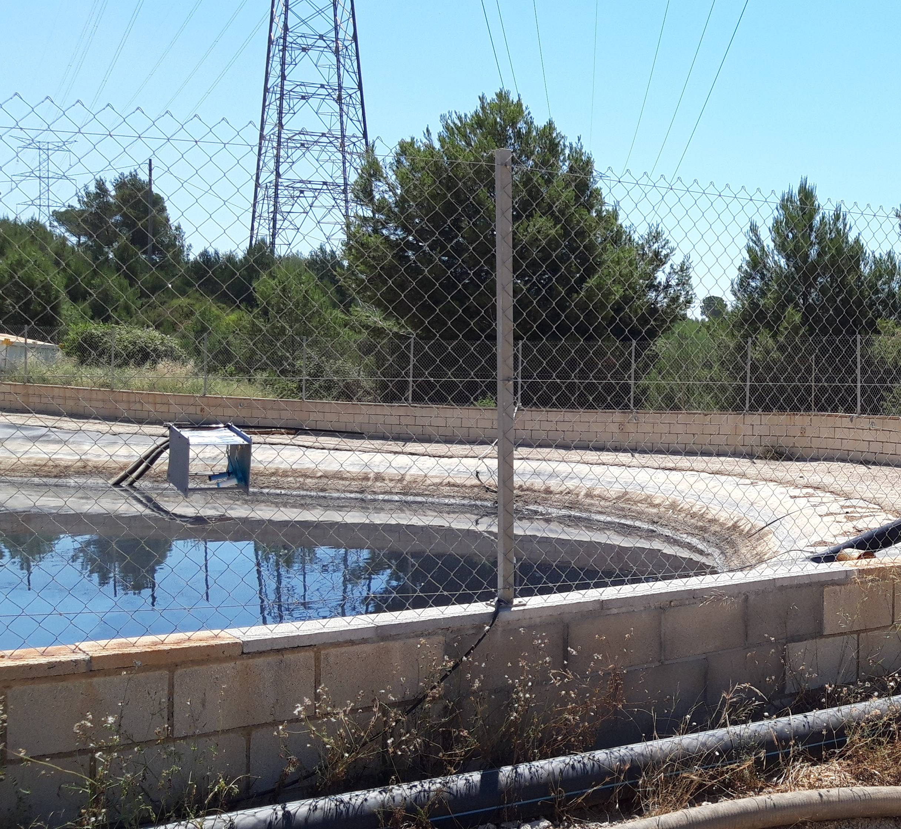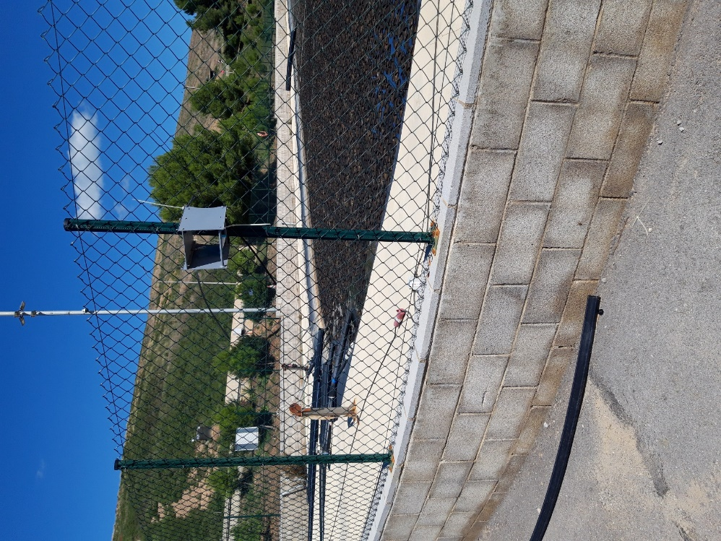
Figure 1. Leachate basin. H₂S sampling during July 2020 (left) and September 2025 (right) campaigns.
    - H₂S analytical methodology
Radiello H₂S cartridge adsorbents were treated according to the specifications of the Radiello method for the determination of hydrogen sulphide in air, with subsequent analysis by spectrophotometry (absorbance at 665 nm, Specord 200 Plus, Analytik Jena). Methylene blue solution (reference RAD171) was used for sample quantification.
    - Odours calculation
Odour units were calculated using the H₂S field-measured concentrations and its odour threshold. Several references were reviewed to establish this threshold (Leonardos et al., 1969, Nagata, 2003, van Gemert, 2003, UK Environmental Agency, 2007, AIHA, 2013), which was set at 0.7 µg m⁻³.
    - Dispersion model used
The method used to determine the surface emission of H₂S at Can Mata landfill is based on mass concentrations obtained experimentally from sampling at various points in the leachate basins, as described in the previous section. This is an indirect method, known as inverse modelling, in which the emission rates of existing surface sources are determined based on the concentrations measured at immission through chemical analysis (Gallego et al., 2024).
The relationship between immission concentrations and emission rates can be established using different atmospheric dispersion models for chemical substances. In this case, the selected model is The Atmospheric Pollution Model (TAPM) developed by CSIRO (Australia). TAPM model solves the fundamental fluid-dynamic transport equations to predict both meteorology and pollutant concentrations for air quality assessment and management applications. TAPM consists of coupled meteorological forecasting components and air pollution components. Surface meteorological observations from the study area are incorporated into the calculations. The model predicts key local-scale processes affecting pollution, such as sea breezes and terrain-induced flows, based on meteorological data derived from synoptic-scale analyses. The meteorological component of TAPM is a system of differential equations for incompressible, non-hydrostatic flow that follows terrain contours for three-dimensional simulations. The model solves the vector momentum equations for horizontal wind components, the continuity equation for the vertical component, and scalar equations for virtual potential temperature, specific humidity of water vapor, cloud water, and rainwater. The air pollution component of TAPM uses the meteorological outputs through four modules. The Eulerian module solves differential equations for concentration forecasting and the cross-correlation between concentration and virtual potential temperature. The Lagrangian particle module can be used to study dispersion close to the emission source. The plume rise module accounts for buoyancy and momentum effects of point source emissions (e.g., stacks). Finally, the building effect module considers the influence of structures on pollutant dispersion and is applied in both the Eulerian and Lagrangian modules (Hurley, 2005).
    - Meteorological data
Meteorological data from a local station, located within the Can Mata landfill site, were assimilated into the meteorological module to calculate air velocities and other necessary meteorological parameters for subsequent transport and dispersion modelling of pollutants. These local data were given priority over those calculated from synoptic mesoscale meteorological data for the area.
    - Calculation hypothesis
The relationship between the emission rate at a given location, expressed as mass per unit time (e.g., g s⁻¹), and the immission concentration at a given point, expressed as mass per unit volume of air (e.g., g m⁻³), over a specific time period, is linear. This means that if the emission rate is doubled, the resulting concentration will also be twice as high as the original. This assumption has been verified through multiple runs of the software using different datasets. Furthermore, when performing mass balance calculations in a dynamic system, the assumption is consistent. The emission rate from each type of source is considered to be uniformly distributed across the entire emitting surface (Gallego et al., 2024).
  - Results
    - H₂S concentrations and Odour units
Table 1 presents H₂S concentrations and odour units related to H₂S concentrations in the three evaluated points of the leachate basin in 2020 and 2025. It has to be noted that a single sample was taken in 2020 and duplicate samples were taken in 2025.
As can be observed, the concentrations measured at the three sampling points in the leachate basin in 2025 are substantially lower, by nearly one order of magnitude. Differences among the thee sampling points in each sampling campaign are related to their relative location in the basin and the dominant winds. The average concentration of the three sampling points of the leachate basin was 954 ± 168 µg m⁻³ in 2020 (n = 3), whereas in 2025 the average concentration was 117 ± 16 µg m⁻³ (90-139 µg m⁻³) (n = 6), corresponding to a concentration reduction of 87.7%. The results are consistent with previous studies on landfill leachate activities, which have reported ambient air H₂S concentrations in surrounding areas ranging from 20 to 3,800 µg m⁻³ (Izady et al., 2026).

Table 1. H₂S concentrations (µg m⁻³) and Odour units (O.U.) at the different evaluated sampling points of the leachate basin.
Control point | 2020 | 2020 | 2025 | 2025
Control point | µg m⁻³ | O.U. | µg m⁻³ | O.U.
Leachate basin P1 | 1127 | 1609 | 129 ± 13 | 184 ± 20
Leachate basin P2 | 946 | 1351 | 121 ± 2 | 173 ± 4
Leachate basin P3 | 791 | 1129 | 101 ± 15 | 143 ± 21

Applying the odour threshold to transform concentrations into odour units, the results show that H₂S O.U. without the installed cover system presented an average value of 1363 ± 240 O.U, while with the installed covering system odour units decreased to 167 ± 23 O.U. (128-198 O.U.).
It has to be acknowledged that the sampling campaigns were not conducted in the same months of the year. Different temperature and humidity parameters can influence seasonal H₂S emissions (Hassan et al., 2025), independently of the coverage used to reduce leachate odorous flows. A difference of 6°C was observed between the average temperatures recorded during the two campaigns, with higher temperatures measured in the 2020 campaign, consistent with higher H₂S concentrations expected at higher temperatures (Zheng et al., 2021).
    - Impact reduction in the leachate basins
Given that meteorological conditions—particularly temperature and humidity—can influence the volatilization of compounds, emission factors for 2020 and 2025 were calculated using the specific meteorological data recorded during each sampling period, in order to enable a robust comparison of the reduction in impact.

Figure 2. Leachate basin 2020 impact map. Theoretical concentrations obtained through the mathematical model assuming a typical theoretical emission flow rate. Colour code shows relative concentrations: red colour, higher concentration; blue colour, lower concentration. (Figure previously published in Gallego E., Perales J.F., Aguasca N., Domínguez R., 2024. Determination of emission factors from a landfill through an inverse methodology: Experimental determination of ambient air concentrations and use of numerical modelling, Environmental Pollution, 351, 124047.

Applying the methodology described above, emission rates from the leachate basin for 2025, when the basin was covered, were determined using atmospheric dispersion modelling, and compared with the results obtained in 2020, when the basin was uncovered (Gallego et al., 2024). The application of the obtained results led to a slightly lower reduction than that calculated directly using the measured concentrations. The resulting value for the reduction in emissions using this indirect methodology was 86.2%.
Impact maps obtained with the mathematical model for the 2020 and 2025 are presented in Figures 2 and 3. Note that colours show relative concentrations, as the absolute values depend on the emission flows. As previously said, only changes in H₂S emission concentrations were considered regarding the impact maps, VOCs and NH₃ emission concentrations were considered equal to 2020.

Figure 3. Leachate basin 2025 impact map. Theoretical concentrations obtained through the mathematical model assuming a typical theoretical emission flow rate. Colour code shows relative concentrations: red colour, higher concentration; blue colour, lower concentration.

As illustrated by the previous figures, the implemented leachate basin covering system has demonstrated effective performance in reducing odorous emissions, particularly those associated with H₂S generated at the landfill. These findings support the adoption of this site-specific mitigation measure as a sustainable and socially acceptable approach to landfill management (Lakhouit, 2026).
  - Conclusions
The implementation of hexagonal-shaped HDPE cover elements in the leachate reservoir of the Can Mata landfill has demonstrated a highly effective reduction in odorous emissions. An 87.7% reduction in H₂S concentrations has been observed between July 2020 and September 2025. Atmospheric dispersion modelling using TAPM, incorporating site-specific meteorological conditions, confirmed the effectiveness of the mitigation measure, yielding a consistent reduction in emissions of 86.2%. The agreement between measured concentrations and modelled emission reductions supports the robustness of the applied methodology and highlights the importance of accounting for meteorological variability in impact assessments.
Overall, the results demonstrate that hexagonal HDPE covering systems are an efficient and reliable solution for significantly reducing H₂S emissions and associated odour nuisance from landfill leachate reservoirs. This approach represents a valuable mitigation strategy for improving environmental performance and minimizing the impact of landfill operations on surrounding areas.
Acknowledgments
This work was supported by the Technical support agreement C-13278 between UPC and Prezero Gestión de Residuos.

References
AIHA (American Industrial Hygiene Association), 2013. Odor Thresholds for Chemicals with Established Occupational Health Standards. USA.
D’Aoust P.M., Szulc P.J., Houweling D., 2026. Evaluating hydrogen sulfide removal from municipal landfill leachate using a venturi stripping system, Waste Management, 211, 115288.
Gallego E., Perales J.F., Aguasca N., Domínguez, R., 2024, Determination of emission factors from a landfill through an inverse methodology: Experimental determination of ambient air concentrations and use of numerical modelling, Environmental Pollution, 351, 124047.
Hassan S.Z., Sun P.P., Chen J., Reinart D., 2025. A review of landfill odors assessment: Advancing from stationary measurement to spatiotemporal monitoring. Waste Management 206, 115086.
Hurley P.J., 2005. The Air Pollution Model (TAPM) Version 3. Part 1: Technical Description, vol. 330. CSIRO Atmospheric Research, Australia.
Izady A., Al-Maktoumi A., Chen M., Al-Mamari H., Nkambule T.T.I., Msagati T.A.M., 2026, Review of environmental, ecological, and public health impacts from municipal landfill leachates Journal of Environmental Engineering and Science, 21, 9-24.
Lakhouit A., 2026. Landfill emissions and environmental Challenges: A comprehensive review, Fuel, 417, 138671.
Leonardos G., Kendall D., Barnard N., 1969. Odour threshold determinations of 53 odorant chemicals. Journal of Air and Pollution Control Association, 19, 91–95.
Muezzinoglu A., 2025. A review of odor problems from landfills, Chapter In: A. Anouzla, S. Souabi, T.A. Kurniawan (Eds), Handbook of the Effects of Landfill Emissions on Sustainable Development, Springer Cham, Switzerland.
Nagata N., 2003. Measurement of odor threshold by Triangle odor Bag method. Odour Mesaurement Review 118–127. Japan Ministry of the Environment.
Oliva G., Giaquinto D., Napodano P., Limongiello M., Barba S., Vivarelli A., Cardona G., Belgiorno V., Zarra T., Naddeo V., 2024, Fugitive Gaseous Emissions Characterization from Municipal Solid Waste Landfill by a New Integrated Approach: Field Surveys and Remote Sensing, Chemical Engineering Transactions, 112, 205-210.
Ren Y., Zhang R., Zhang L., Wang H., Zhang X., Bai, Z., Ma L., Wang X., 2025. The Characteristics of Key Odorants from Livestock Farms and Their Mitigation Potential: A Meta-Analysis, Atmosphere, 16, 1097.
Szałata L., Zwoździak J., Majerník M., Cierniak-Emerych A., Jarossová M. A., Dziuba S., Knošková L., Drábik P., 2021, Assessment of the odour quality of the air surrounding a landfill site: A case study, Sustainability, 13, 1713.
UK Environmental Agency, 2007. Review of Odour Character and Thresholds. Science Report SC030170/SR2,UK.
van Gemert, L.J., 2003. Compilations of Odour Threshold Values in Air and Water. (TNO Nutrition and Food Research Institute). Boelens Aroma Chemicals Information Service (BACIS), The Netherlands.
Verma G., Chetri J.K., Reddy K.R., 2025, Development of New Large-Scale Test Setup for Simulating Bio- and Biogeochemical-Based Covers for Landfill Gas Mitigation, Chapter In: A. Farid A., K. Foye, M.V. Khire (Eds) Geo-EnvironMeet 2025, Geoenvironmental contamination and waste containment, The American Society of Civil Engineers, Virginia, USA.
Vizuete-Montero M., Chaglla-Cango M., Cuadrado-Andrade J., León-Terán J., 2025, HDPE geomembrane-based artificial cover system for landfill in mitigating mercaptan emissions from organic waste, Waste Management Bulletin, 3, 100231.
Zhang Y., Ning X., Li Y., Wang J., Cui H., Meng J., Teng C., Wang G., Shang X., 2021, Impact assessment of odor nuisance, health risk and variation originating from the landfill surface, Waste Management, 126, 771-780.
Zhang J., Li X., Quian A., Xu X., Lv Y., Zhou X., Yang X., Zhu W., Zhang H., Ding Y., 2024. Effects of operating conditions on the in situ control of sulfur‑containing odors by using a novel alternative landfill cover and its transformation mechanism, Environmental Sience and Pollution Research, 31, 7959-7976.
Zheng T., Li L., Chai F., Wang Y., 2021. Factors impacting the performance and microbial populations of three biofilters for co-treatment of H2S and NH3in a domestic waste landfill site. Process Safety and Environmental Protection, 149, 410-421.

